INTERNSHIP / UDP / TRAINING REPORT – REPORTING 4
(Final Project Completion, Demonstration & Evaluation Report)
1. Student Information
Student Name | DHRUVI MALANKIYA
Enrollment Number | 23SE02CE056
Program/Branch | B.TECH / COMPUTER ENGINEERING
Semester | 7th
Contact Number | 9313779161
Email ID | 23se02ce056@ppsu.ac.in

2. Internship / UDP / Training Details
Type | INTERNSHIP
Company/Organization | DURVASA INFOTECH
Department/Domain | PYTHON DATA SCIENCE
Mentor Name (Company) | DARSHAN CHAUHAN
Mentor Name (Institute) | Dr. JAYSHRI PATIL
Start Date | 01/06/2026
End Date | 15/10/2026

3. Work Progress Summary
- Project Title:
Smart Healthcare Analytics System

b) Brief Overview of Work Completed After Reporting 3
At the time of Reporting 3 the Smart Healthcare Analytics System was already running as a complete full-stack application, with the React frontend connected to the Node.js and Express backend, MongoDB storing all the user data, and the Python FastAPI service generating diabetes risk predictions. The work planned before Reporting 4 was therefore not fresh module development but completion, correction and verification. Automated test cases had not been written at that stage, the REST API had no formal documentation, and the forgot password feature was returning the reset token directly in the API response because no email service had been configured. A detailed review of the source code was carried out at the beginning of this phase, and it revealed three defects which were quietly reducing the accuracy of the analytics module. All of this work has now been completed. The application has been verified with a total of 180 test cases, of which 149 are automated Jest and Supertest cases that can be re-run with a single command, and all 180 have passed.
- Major tasks completed: Development of an automated test suite using Jest [9] and Supertest, preparation of the complete REST API documentation using the OpenAPI 3.0 specification [10] served through Swagger UI, integration of an email service for the password reset flow, completion of the health record data capture so that the analytics module receives real values, development of a threshold based health alert engine, development of the data export and account deletion facility, and correction of the defects identified during the code review.
- Modules completed: Health Alert module which screens the latest reading against published clinical reference ranges, Data Export module producing CSV and JSON downloads, Account Management module covering change password, account preferences and permanent account deletion, Email Service module for password reset delivery, API Documentation module, and the Automated Testing module containing seven test suites. The Health Records, Analytics, Risk Assessment, Daily Planner, Health Profile, Reports and Dashboard modules which were developed earlier have been completed and corrected in this phase.
- New features implemented: Threshold based health alerts with three severity levels, clinical reference bands drawn on every analytics chart, ten additional health record fields covering sleep, water intake, exercise, calorie intake, step count, mood, weight, height, resting heart rate and systolic blood pressure, automatic calculation of BMI from height and weight, password reset delivered by email instead of being returned in the API response, storage of the reset token as a SHA-256 digest instead of plain text, change of password from inside the application, account preferences stored on the server so that they follow the account across devices, export of health data as CSV and of the full account as JSON, permanent account deletion with password confirmation, and interactive API documentation served at /api/docs.
- Research / development work completed: The clinical reference ranges used by the alert engine were taken from published sources rather than being chosen arbitrarily. The blood pressure categories follow the 2017 ACC/AHA guideline [5], the fasting plasma glucose thresholds follow the Standards of Care of the American Diabetes Association [6], and the BMI classification follows the World Health Organization report [7]. The trained Random Forest model was re-trained and re-evaluated on the present environment in order to confirm that the results reported in Reporting 3 are reproducible. Accuracy, precision, recall, F1-score and both confusion matrices were reproduced exactly, while the ROC-AUC value moved from 81.70 percent to 81.52 percent. The cause was traced to the scikit-learn [3] version, which had moved from the version used during Reporting 3 to version 1.9.0, because the requirements file specifies minimum versions rather than exact versions. ROC-AUC is computed from predicted probabilities and not from the final class labels, which is why it can shift slightly while every prediction at the 0.5 threshold stays the same. The figure of 81.52 percent is the one reported here, since it is the value the present environment reproduces on every run.
- Integration work completed: Four new endpoint groups were added to the centralized frontend API service and connected to the interface. The Express backend was integrated with Nodemailer for outbound email, with a capture inbox used automatically when no SMTP credentials are configured so that the reset flow can be demonstrated without hard-coding any mail password. Swagger UI was integrated into the Express application to serve the OpenAPI document. The Express application was separated from the server entry point so that the test suite can drive it in memory without opening a network port. The complete flow from the React interface to the Express server, to the FastAPI service, to MongoDB and back was executed in a real browser across all thirteen dashboard pages, and no console error was produced on any page.

c) Overall Project Completion Status
Component | Status | Completion (%)
Requirement / Analysis | Completed | 100 %
Design | Completed | 100 %
Development | Completed | 100 %
Integration | Completed | 100 %
Testing | Completed | 95 %
Documentation | Completed | 100 %
Deployment | In Progress | 20 %
Overall Project Completion: 92 % (calculated by giving higher weightage to development, integration and testing, which form the major part of this phase. Cloud deployment is the only component which remains substantially incomplete.)

4. Advanced Implementation
After Reporting 3 the implementation work was concentrated on four areas, namely completion of the features which were only partly built, correction of the defects found during the code review, addition of the security and data ownership facilities that the application was claiming but not providing, and preparation of the automated tests and the API documentation required before the final demonstration.
a) Module / Feature Implementation
Module / Feature | Work Completed | Status
Health Record Data Capture | Ten fields added to the entry form and to the server, covering sleep, water, exercise, calories, steps, mood, weight, height, heart rate and systolic blood pressure. BMI is now derived automatically from height and weight. | Completed
Health Alert Engine | A dependency free screening module of 245 lines which compares the latest reading against published clinical thresholds and returns alerts at three severity levels, served through two protected endpoints. | Completed
Clinical Reference Bands | All six analytics charts now show the normal range as a shaded band and the abnormal limit as a dashed line, with separate axes where two units are plotted together. | Completed
Email Service | Nodemailer [11] service with real SMTP when credentials are supplied and an automatic capture inbox when they are not, so the reset mail can still be opened during a demonstration. | Completed
Password Reset Hardening | The reset token is no longer returned by the API. Only its SHA-256 digest is stored, the link expires in fifteen minutes and is single use, and the token is cleared if the mail fails. | Completed
Account Management | Change of password with verification of the current password, account preferences stored on the user document, and permanent account deletion which removes every record owned by the account. | Completed
Data Export | Health records download as an RFC 4180 CSV file and the full account downloads as JSON. Neither export contains the password hash or the reset token. | Completed
REST API Documentation | An OpenAPI 3.0 document of 1,054 lines covering 36 operations in ten tag groups, served as an interactive page at /api/docs and as raw JSON at /api/docs.json. | Completed
Automated Test Suite | Seven Jest suites with 149 test cases running against a dedicated test database. Statement coverage is 73.45 percent overall and 88.47 percent across the controllers. | Completed
Access Control on Hospital Layer | The thirty eight administration endpoints, previously reachable without any token, are now behind the authentication middleware and an administrator role check. | Completed
Reporting Date Correction | All reporting queries were changed from the database insertion timestamp to the clinical record date, which had been collapsing every record of a user onto one point of the charts. | Completed
Calendar Date Correction | Streak and heatmap date keys are now built from local calendar fields instead of a UTC conversion, which had shifted both by one day, and the heatmap now includes the current day. | Completed
Database Index Optimisation | Three indexes were added, one compound index on the health records and two on the prediction history, removing the collection scans behind the dashboard and report queries. | Completed
Security and Session Corrections | Sign out now clears the token, a token for a deleted account returns 401 instead of a server error, record updates accept only whitelisted fields, and forms can no longer be double submitted. | Completed
Machine Learning Verification | The model was re-trained on the current environment to confirm reproducibility and the ML documentation was corrected to match the generated evaluation report. | Completed
Cloud Deployment | Deployment of the frontend, backend, machine learning service and database on a cloud platform. | Pending
Additional Disease Models | Heart disease and hypertension risk models to be trained and added to the FastAPI service. | Pending
b) Integration / Development Details
- Module integration : The four new endpoint groups, namely alerts, export, account preferences and change of password, were added to the centralized API service file, which now contains 35 methods in nine groups. The alert panel was added to the dashboard and the notification menu in the top bar was connected to the same alert endpoint, replacing the three fixed notification strings which were shown earlier. The Settings page was rebuilt around the new endpoints, and the profile photo and name now refresh the cached account through a new refresh function in the authentication context instead of the incorrect call which was being made earlier.
- API integration, if applicable : The backend now exposes 75 REST endpoints, which is nine more than at Reporting 3. Of these, 37 belong to the user facing application and 38 belong to the hospital administration layer. All 38 administration endpoints and 31 of the 37 user facing endpoints require a valid JSON Web Token [4], and the administration endpoints additionally require the administrator role. The six endpoints which remain public are the service health check, the API document itself, registration, login, forgot password and reset password, and the last four of these are protected by a rate limit of ten requests in fifteen minutes. The global limit on all other API routes was raised from 100 to 300 requests in fifteen minutes, because a single dashboard load now issues several parallel requests and a user navigating normally was able to exhaust the earlier limit.
- Database integration : The number of collections is unchanged at twelve. Three new indexes were created, taking the total to ten, and an account preferences sub-document was added to the user schema. The minimum password length is now enforced inside the pre-save hook of the user schema rather than as a schema validator, because the hook replaces the password with a sixty character bcrypt hash before Mongoose runs its validators, which meant the earlier length rule was only ever measuring the hash and never the password the user typed. Deletion of a health record continues to remove its prediction history, and deletion of an account now removes every document belonging to that user.
- Hardware integration, if applicable : Not applicable. The project is a web based software application and does not use any external hardware device or sensor.
- Software integration : The system continues to run as three application services together with the MongoDB server, on ports 3000, 5001, 8000 and 27017 respectively. The Express application was separated from the server entry point into two files, so that the test suite can load the application in memory through Supertest without opening a network port, while the entry point remains responsible for connecting to the database and listening. The rate limiters detect the test environment and step aside by default, since every test request originates from the same address and would otherwise exhaust the limit part way through a run, and one suite switches them back on deliberately in order to test the limit itself.
- Major coding / development work : Approximately 4,987 lines of code were written after Reporting 3. This consists of 3,505 lines in twenty one new files and 1,482 lines added to existing files, against 466 lines removed. Of the new code, 1,554 lines are test code and 1,951 lines are application code. The largest single additions are the OpenAPI document at 1,054 lines, the test suites at 1,554 lines across ten files, the alert engine at 245 lines, the alert panel component at 183 lines, the email service at 135 lines and the export controller at 112 lines.
c) Final / Updated Architecture
The final system architecture of the Smart Healthcare Analytics System after the work completed in this phase is given below.
Diagram:
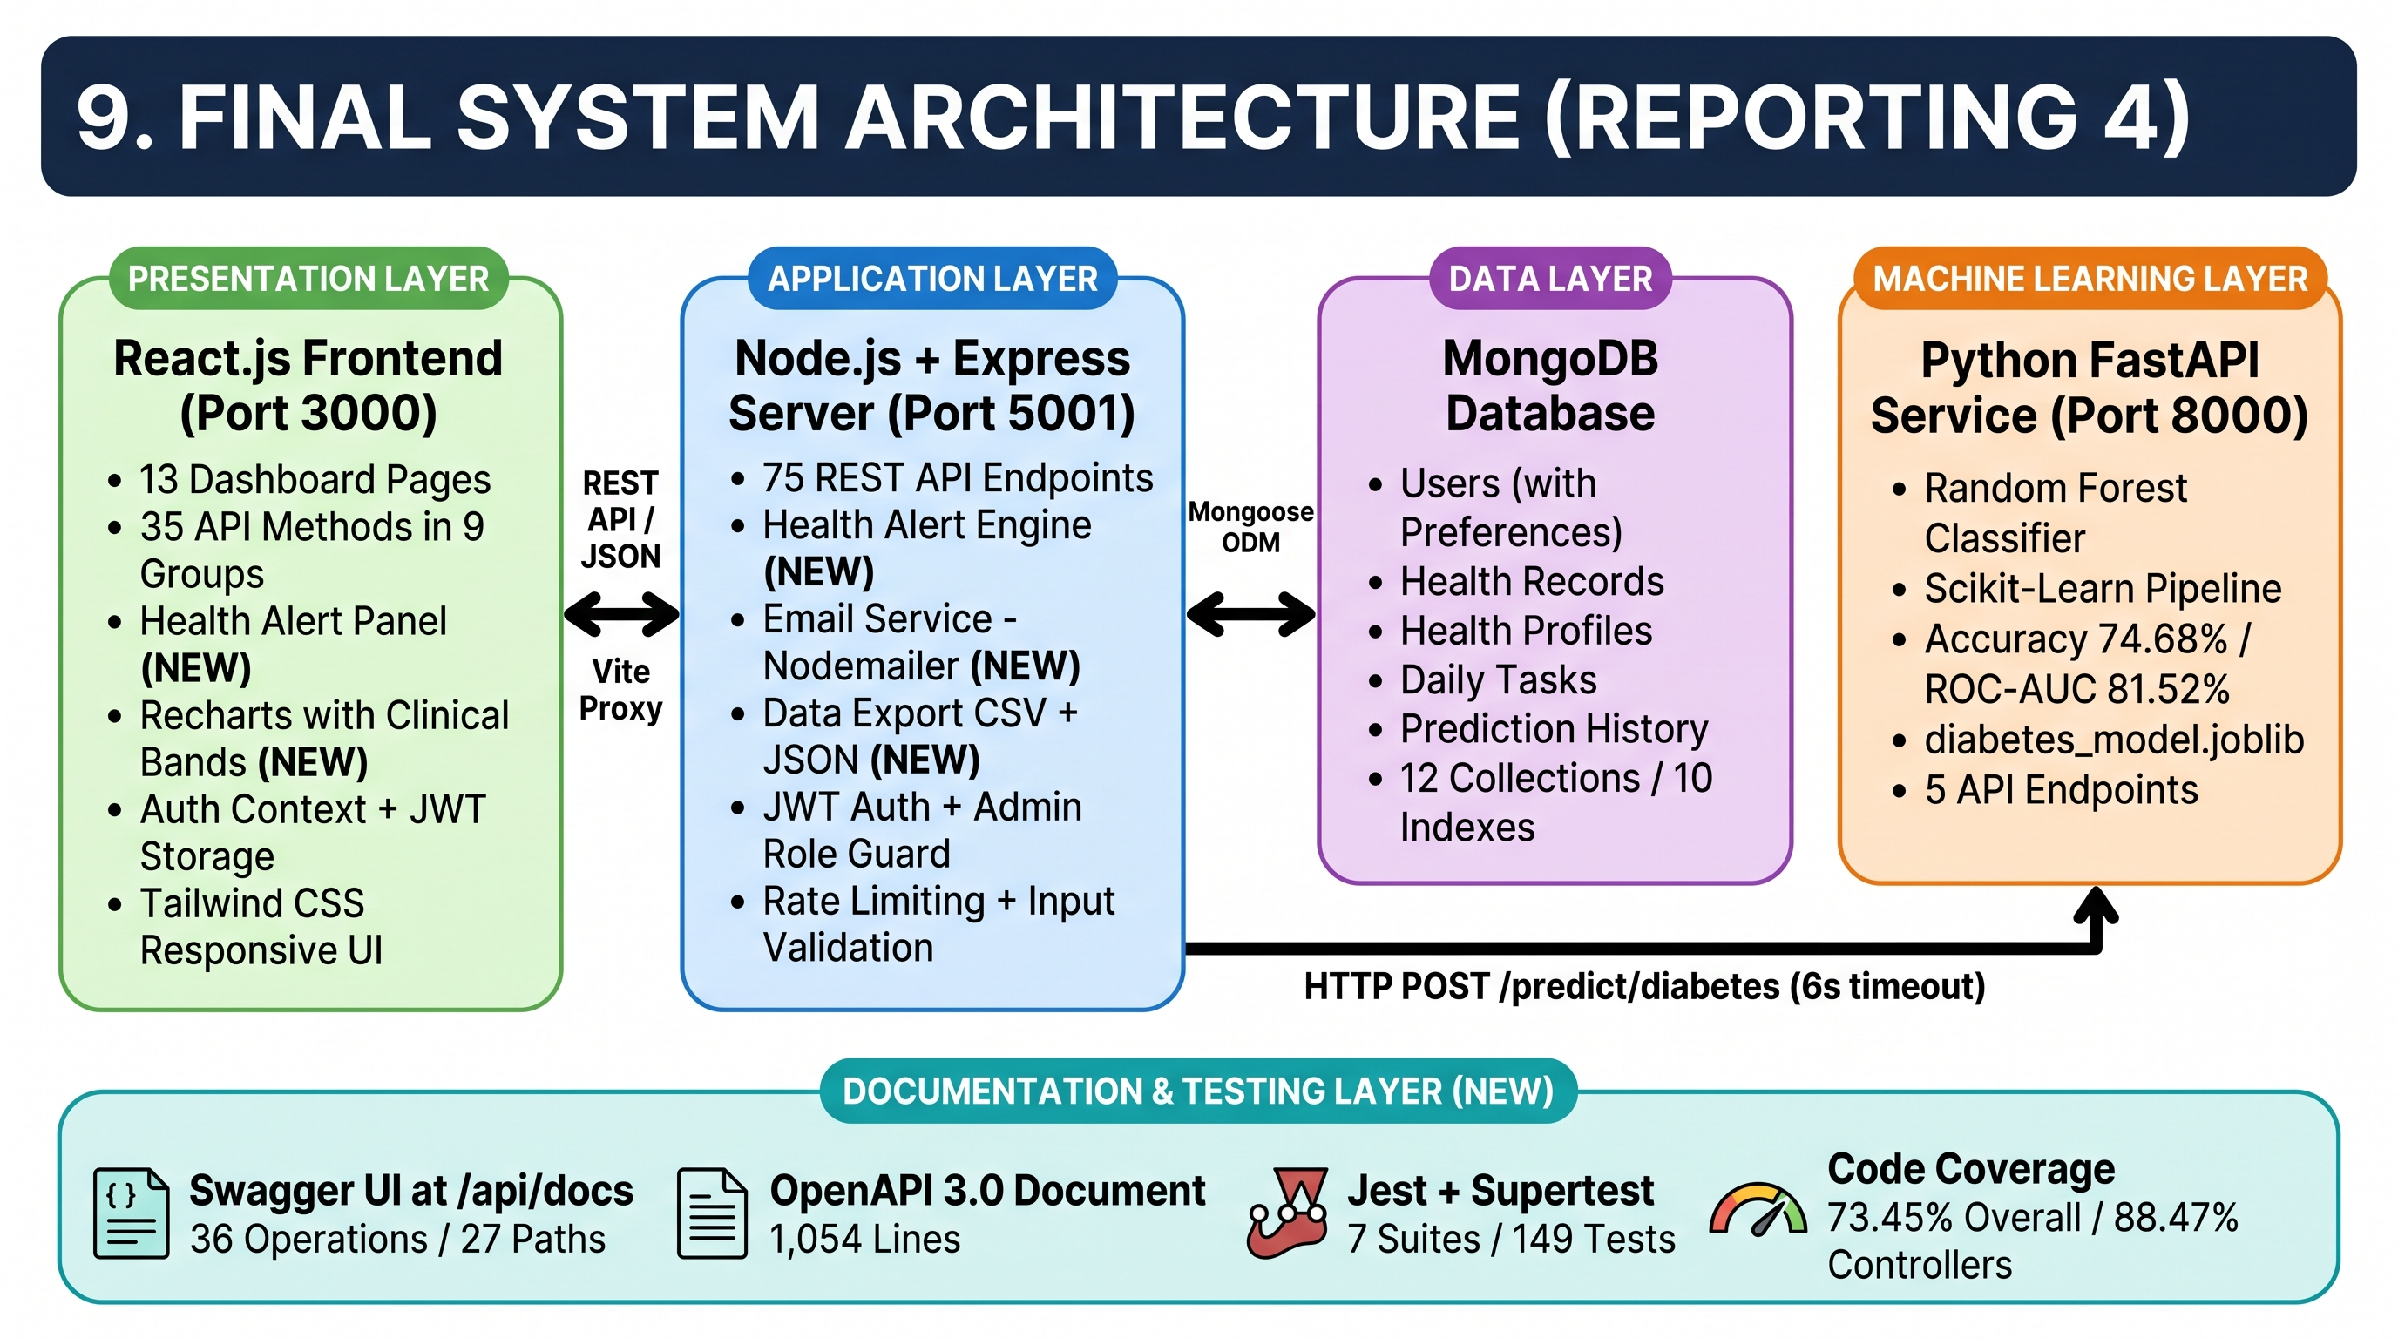
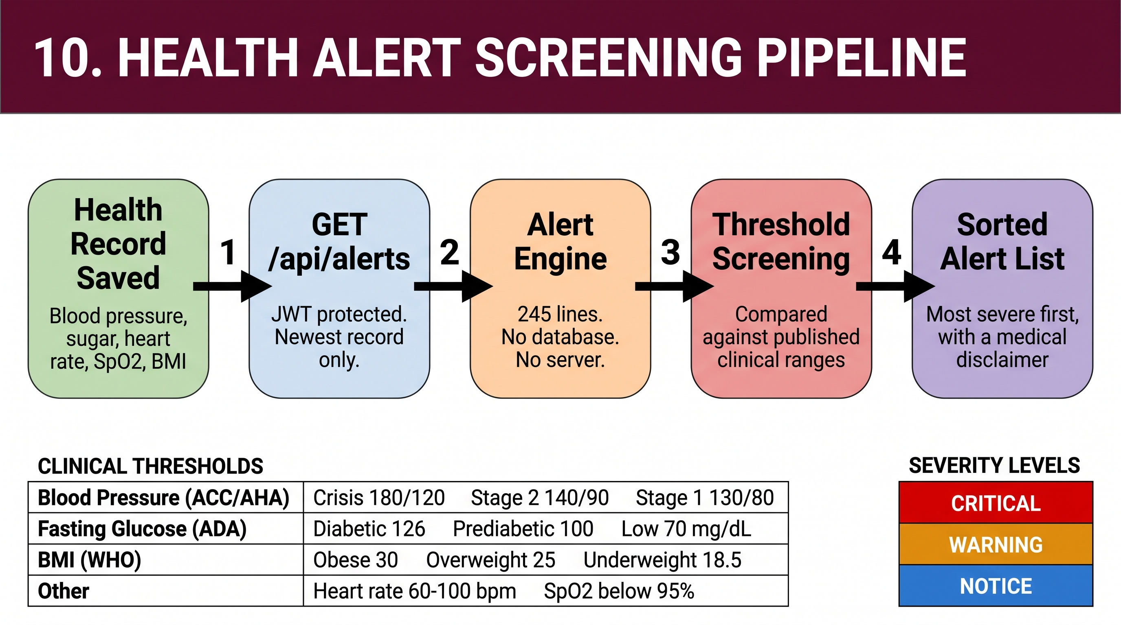
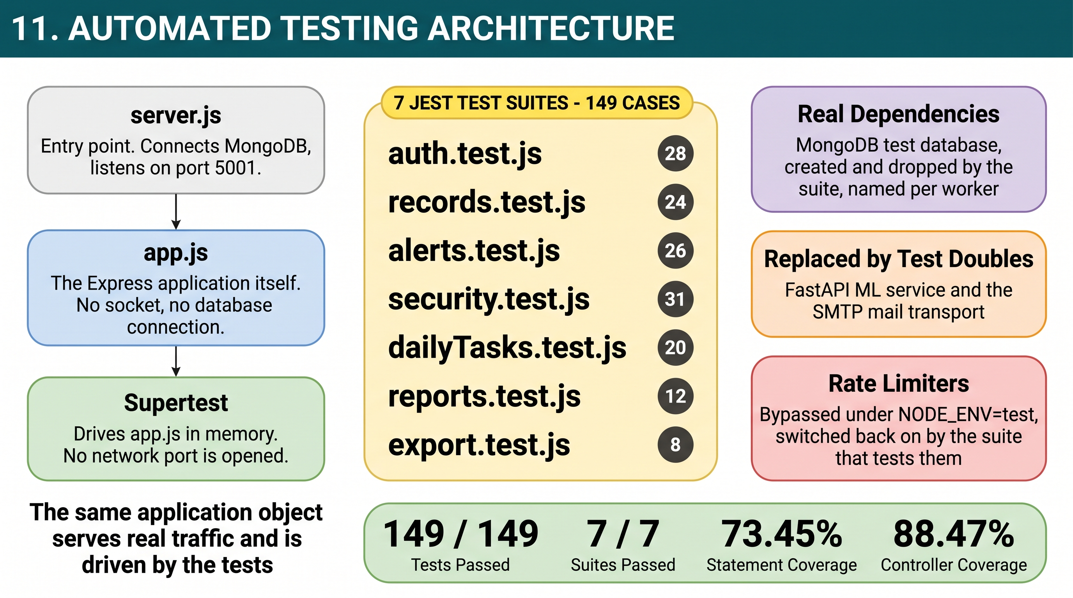
Brief Explanation:
The architecture of the system has not changed in its shape during this phase. It remains a three tier application with a separate machine learning service, and the diagrams above show the same structure with the components that were added after Reporting 3 marked on it.
Three components are new in the application layer. The alert engine is a pure module which receives the most recent health record and the most recent prediction and returns a list of alerts. It performs no database access of its own, which is why it can be tested directly with twenty one unit test cases that need neither a database nor a running server. The email service sits between the authentication routes and the outside world and chooses its transport at runtime, using real SMTP when credentials are present and a capture inbox when they are not. The export controller reads the four collections belonging to the signed in user and streams the result as a file rather than as a JSON response.
The documentation layer is also new. The OpenAPI document is a plain JavaScript module rather than a set of comments spread across the route files, so that the specification can be read and reviewed on its own, and it is served both as an interactive page and as raw JSON.
The most significant change is not visible as a new box on the diagram. The Express application was split away from the server entry point, so that the same application object which serves real traffic is also the object the test suite drives in memory. This means the automated tests exercise the real middleware chain, the real routes and a real MongoDB instance, and only the machine learning service and the mail transport are replaced by test doubles. The test database is created and dropped by the suite itself and is named after the worker process, so a test run can never touch development data.
The prediction path itself is unchanged from Reporting 3. When a health record is submitted the Express server stores it, sends the eight clinical parameters to the FastAPI service, and stores the returned probability, risk level and contributing factors in the prediction history collection. If the machine learning service does not answer within six seconds the record is still saved and the interface reports that the prediction could not be generated, so the application continues to work when the model is unavailable.
5. Final Testing and Validation
The testing carried out in this phase is divided into five areas. The functional and integration cases are automated and are re-run with a single command, while the system, performance and user acceptance checks were carried out on the running application. A total of 180 test cases were executed and all of them passed.
Testing Performed
Testing Area | Tests Conducted | Passed | Failed | Final Status
Functional Testing | 105 | 105 | 0 | Passed
Integration Testing | 44 | 44 | 0 | Passed
System Testing | 13 | 13 | 0 | Passed
Performance Testing | 12 | 12 | 0 | Passed
User Acceptance Testing | 6 | 6 | 0 | Passed
Total | 180 | 180 | 0 | Passed
Testing Methods Used
Functional Testing : 105 automated cases covering the behaviour of individual endpoints and of the alert engine. These check registration and login rules, rejection of weak and duplicate credentials, create, read, update and delete operations on health records and daily tasks, pagination and search, the streak and history calculations, the health profile, the report endpoints, the export endpoints and the twenty one threshold rules of the alert engine.
Integration Testing : 44 automated cases which exercise two or more components working together. These cover the password reset path through the email service, the record creation path through the machine learning service including its failure and timeout behaviour, the cascade deletion of prediction history and of a complete account, ownership checks across modules, and the authentication and role chain protecting the thirty eight hospital administration endpoints.
System Testing : All thirteen protected pages of the dashboard were opened in a real browser with all four services running, after signing in as a seeded user. Each page was checked for correct rendering, for absence of a stuck loading state and for browser console errors. No page produced an error and no network request failed.
Performance Testing : Twelve measurements were taken on the running system. Ten data endpoints were each called twenty times after a warm up, and the machine learning prediction and the login endpoint were measured separately.
User Acceptance Testing : Six complete user journeys were executed end to end on the running application, namely signing in and loading the dashboard with live data, adding a health record with lifestyle values and receiving a risk prediction, raising health alerts from an out of range reading, reading the analytics charts with the clinical bands, completing the forgot password journey from the form through the delivered email to signing in with the new password, and exporting the data and changing the password from the Settings page. Each journey was carried out through the browser in the same way a user would carry it out. Testing with a wider group of external users has been planned for after cloud deployment.
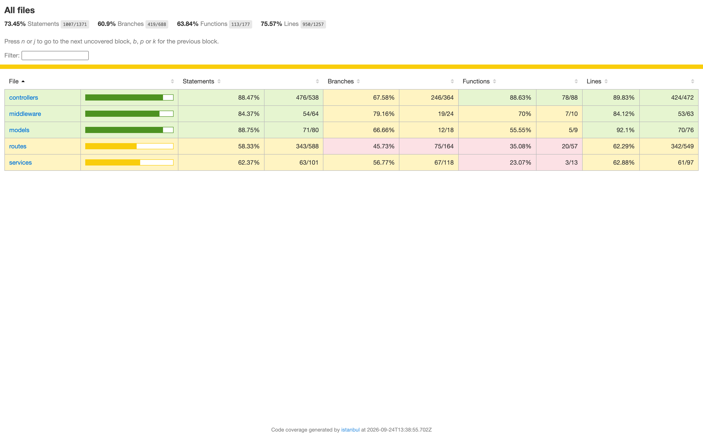
Coverage report generated by the same test run. Statement coverage is 73.45 percent overall and 88.47 percent across the controllers. The lower figure on the routes folder is caused by the hospital administration route files, which have no frontend and are exercised only by the access control tests.
6. Results and Performance Analysis
a) Final Results and Performance Analysis
The Smart Healthcare Analytics System is now a complete and verified application. Every module that was listed as pending in Reporting 3 has been completed except cloud deployment and the two additional disease models, and both of these are recorded honestly as pending in this report.
The most important result of this phase is not a new feature but the correction of three defects which were making the analytics module report the wrong thing. The first was that the reporting queries were filtering on the database insertion timestamp rather than on the clinical date of the reading. Because the seeder inserts all ninety three demonstration records in a single operation, every record of a user carried the same insertion timestamp, and all thirty one records of a user were therefore being drawn on one single point of the chart. After the correction the same user returns thirty one points spread across thirty one distinct dates. The second was that the server was never saving the sleep, water, exercise, calorie, step count, heart rate, weight and height values, so four of the charts and three of the dashboard tiles were permanently showing zero for every user. The third was that the streak counter and the progress heatmap were building their date keys by converting local midnight into UTC, which lands on the previous calendar day in India, so both were shifted by one day and the current day never appeared on the heatmap.
On the security side, the thirty eight hospital administration endpoints which were reachable by any anonymous caller are now refused with 401 without a token and with 403 for a non administrator account, and were confirmed to answer only for an administrator. The password reset token is no longer sent to the browser at all. The complete journey was verified by submitting the form, opening the delivered message, taking the link from it, setting a new password, signing in with the new password, confirming that the old password no longer works and confirming that the same link cannot be used a second time.
The machine learning results were re-verified rather than copied forward. On the same stratified eighty and twenty split with a fixed random state of 42, the Random Forest model again produced an accuracy of 74.68 percent, a precision of 68.29 percent, a recall of 51.85 percent, an F1-score of 58.95 percent and the same confusion matrix of 87 true negatives, 13 false positives, 26 false negatives and 28 true positives. The ROC-AUC reproduced as 81.52 percent rather than the 81.70 percent reported in Reporting 3, for the reason explained in section 3. It should be stated plainly that a recall of 51.85 percent means the model misses about half of the genuinely diabetic cases in the test set, and in a medical application a false negative is the more harmful error. The model is therefore presented as an educational screening aid and not as a diagnostic tool, and improving recall is recorded as the clearest direction for future work.
The response times of the application improved as a result of the new database indexes. Across the ten data endpoints measured, the average response time is 3.0 milliseconds and the slowest single measurement was 9.8 milliseconds. The machine learning prediction responds in an average of 11.5 milliseconds. The login endpoint takes an average of 68.5 milliseconds, which is expected and desirable, because bcryptjs performs a deliberately slow hash comparison in order to resist brute force attacks.
Performance Results
Parameter / Metric | Result Obtained | Expected / Target | Status
1. Automated test cases passed | 149 out of 149 | 100 percent pass | Achieved
2. Total test cases passed including manual | 180 out of 180 | 100 percent pass | Achieved
3. Overall statement coverage | 73.45 % | Above 70 % | Achieved
4. Controller statement coverage | 88.47 % | Above 80 % | Achieved
5. Average data API response time | 3.0 ms | Below 200 ms | Achieved
6. Slowest data endpoint response time | 9.8 ms | Below 200 ms | Achieved
7. Machine learning prediction response time | 11.5 ms | Below 500 ms | Achieved
8. Health alerts endpoint response time | 1.6 ms | Below 200 ms | Achieved
9. Login response time (bcrypt comparison) | 68.5 ms | Below 500 ms | Achieved
10. Total REST API endpoints | 75 endpoints | Minimum 40 endpoints | Achieved
11. Documented API operations | 36 operations over 27 paths | All user facing modules | Achieved
12. Endpoints left unauthenticated by mistake | 0 (38 at Reporting 3) | 0 | Achieved
13. Endpoints that are public by design | 6 of 75 | Only health, docs and credentials | Achieved
14. Browser console errors across 13 pages | 0 errors | 0 | Achieved
15. Model accuracy (re-verified) | 74.68 % | Above 70 % | Achieved
16. Model ROC-AUC (re-verified) | 81.52 % | Above 75 % | Achieved
b) Critical Bugs / Issues
The defects listed below were found during the code review carried out at the start of this phase and during the writing of the automated test suite. Each of them was present in the version demonstrated at Reporting 3. All of them have been corrected, and the more serious ones now have an automated test which fails if the defect returns.
Issue | Severity | Resolution | Final Status
Thirty eight hospital administration endpoints were mounted without any authentication, so any anonymous caller could read or modify those collections. | Critical | Mounted behind the authentication middleware together with an administrator role check. Twenty six automated cases now assert the behaviour. | Resolved
Sign out did not sign the user out. The session token stayed in browser storage and the user could navigate straight back in. | Critical | Both the Settings control and the sidebar control were connected to the logout function, which clears the token and the cached account. | Resolved
Reporting queries filtered and grouped on the database insertion timestamp instead of the clinical date, so records inserted in one batch collapsed onto a single day on every chart. | High | All reporting, dashboard and listing queries now use the record date. A regression test inserts twenty back-dated records and asserts twenty distinct dates. | Resolved
The server never saved the sleep, water, exercise, calorie, step, heart rate, weight and height values, so four charts and three dashboard tiles were permanently zero. | High | The fields were added to the record controller and to the entry form, and a test asserts that each value is persisted. | Resolved
Streak and heatmap date keys were built by converting local midnight to UTC, which resolves to the previous day in any timezone ahead of Greenwich. | High | A shared helper now builds keys from local calendar fields, and the heatmap window was corrected to include the current day. | Resolved
The health record update endpoint copied the whole request body onto the record, so a client could rewrite the owning user or the machine learning status of its own record. | High | The endpoint now accepts only a whitelist of descriptive, body, lifestyle and vitals fields. | Resolved
The password reset token was returned in the API response, shown in the interface and stored in the database in plain text. | High | The token is delivered only by email and only its SHA-256 digest is stored. The stored value is cleared if the message fails to send. | Resolved
The shared button component ignored the disabled property, so every authentication and record form could be submitted more than once while a request was in flight. | Medium | The component now forwards the disabled property and suppresses its press animation when disabled. | Resolved
A valid token belonging to a deleted account left the request without a user, and the handlers then failed with a server error instead of an authentication error. | Medium | The middleware returns 401 when the account no longer exists and 403 when it has been deactivated. | Resolved
Updating the profile photo called the login function with a user object in place of an email and password, so the new photo never appeared. | Medium | A refresh function was added to the authentication context and is used after a photo or name change. | Resolved
The machine learning documentation published an accuracy of 77.92 percent and a recall of 68.52 percent, which did not match the generated evaluation report. | Low | Corrected to the generated values, with the confusion matrices and the library versions added so the figures can be reproduced. | Resolved

Final Validation Statement
Is the project ready for final demonstration/submission?
☑ Yes
☐ Yes, with minor improvements
☐ No

c) Output / Result Screenshots
Screenshot 1:
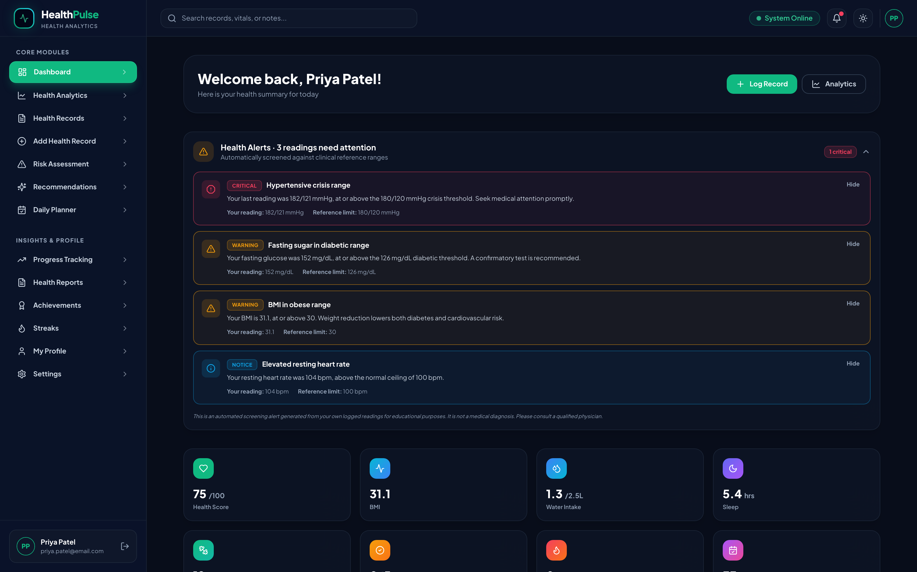
Description:
The dashboard of a signed in user showing the new health alert panel. The alerts are produced by the server from the most recent health record of that user and are sorted with the most severe first. Each alert states the reading that triggered it and the clinical reference limit it crossed, and the medical disclaimer is printed below the list. The heading counts only the readings that need action, so the three it reports are the critical and warning alerts and not the notice below them. The statistic tiles under the panel show the water intake and sleep values, which were permanently zero for every user before the data capture defect was corrected.

Screenshot 2:
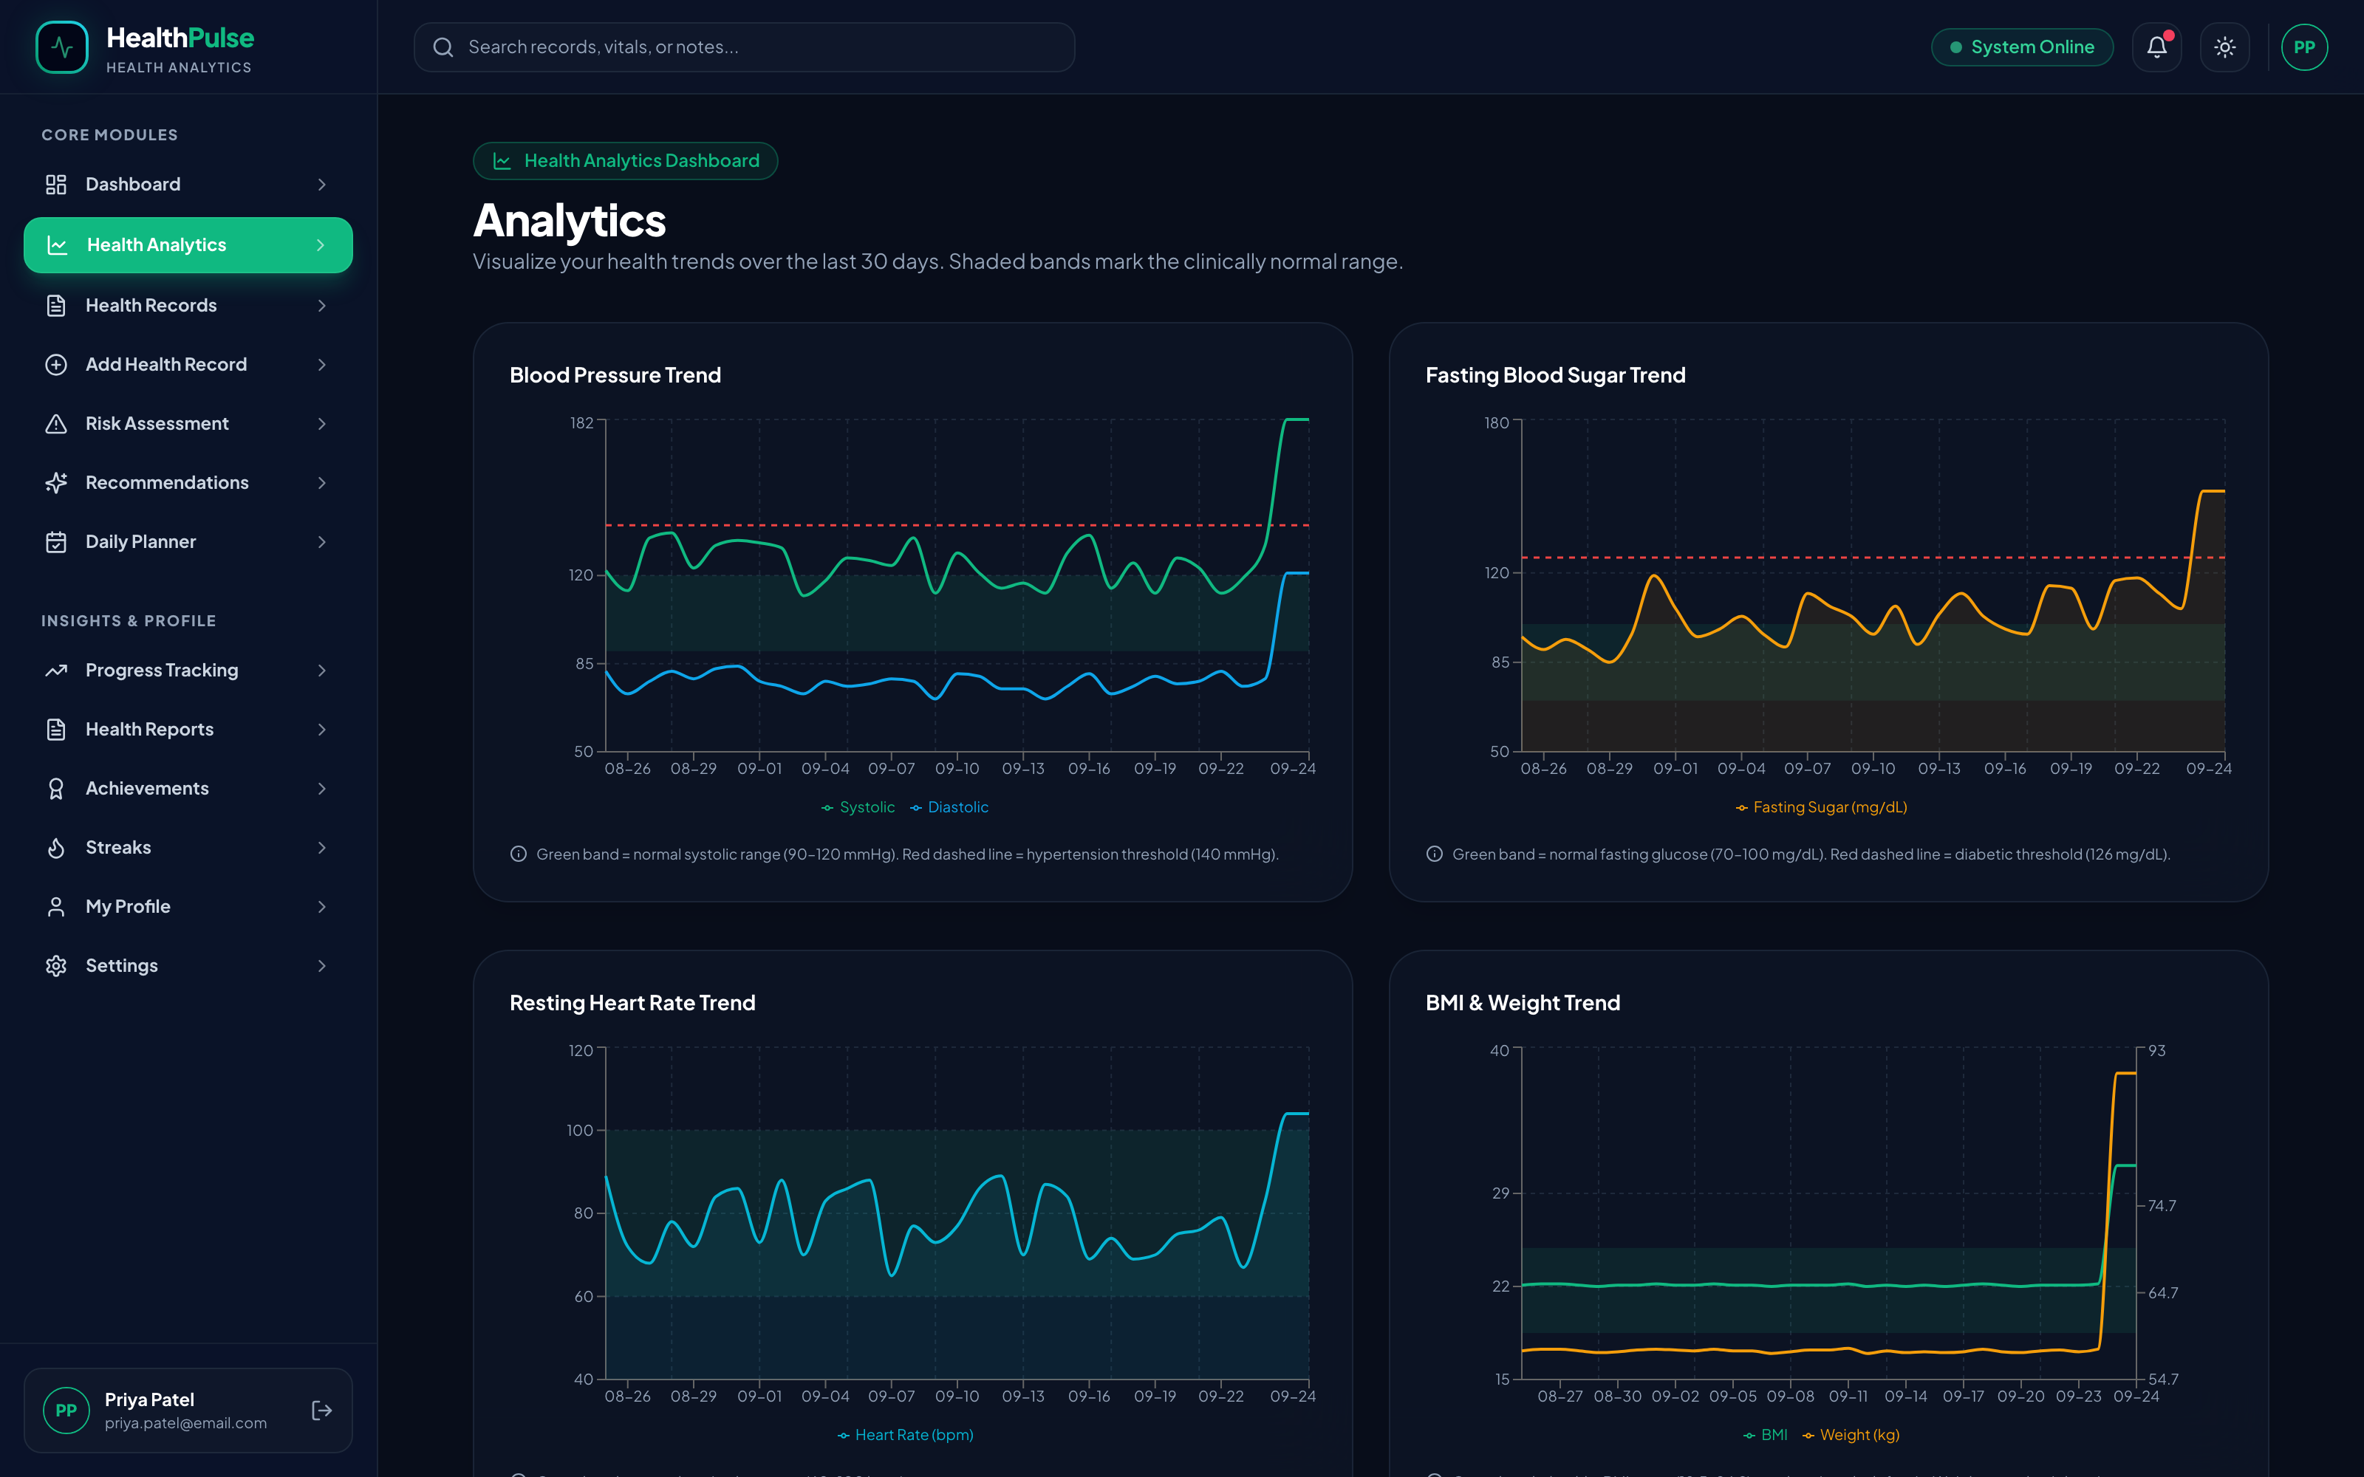
Description:
The analytics page showing four of the six charts. The green shaded band on each chart marks the clinically normal range and the red dashed line marks the abnormal threshold, with the source of each range explained under the chart. The horizontal axis now spreads across thirty one distinct dates, which is the visible result of correcting the reporting queries to use the clinical record date instead of the database insertion timestamp.

Screenshot 3:
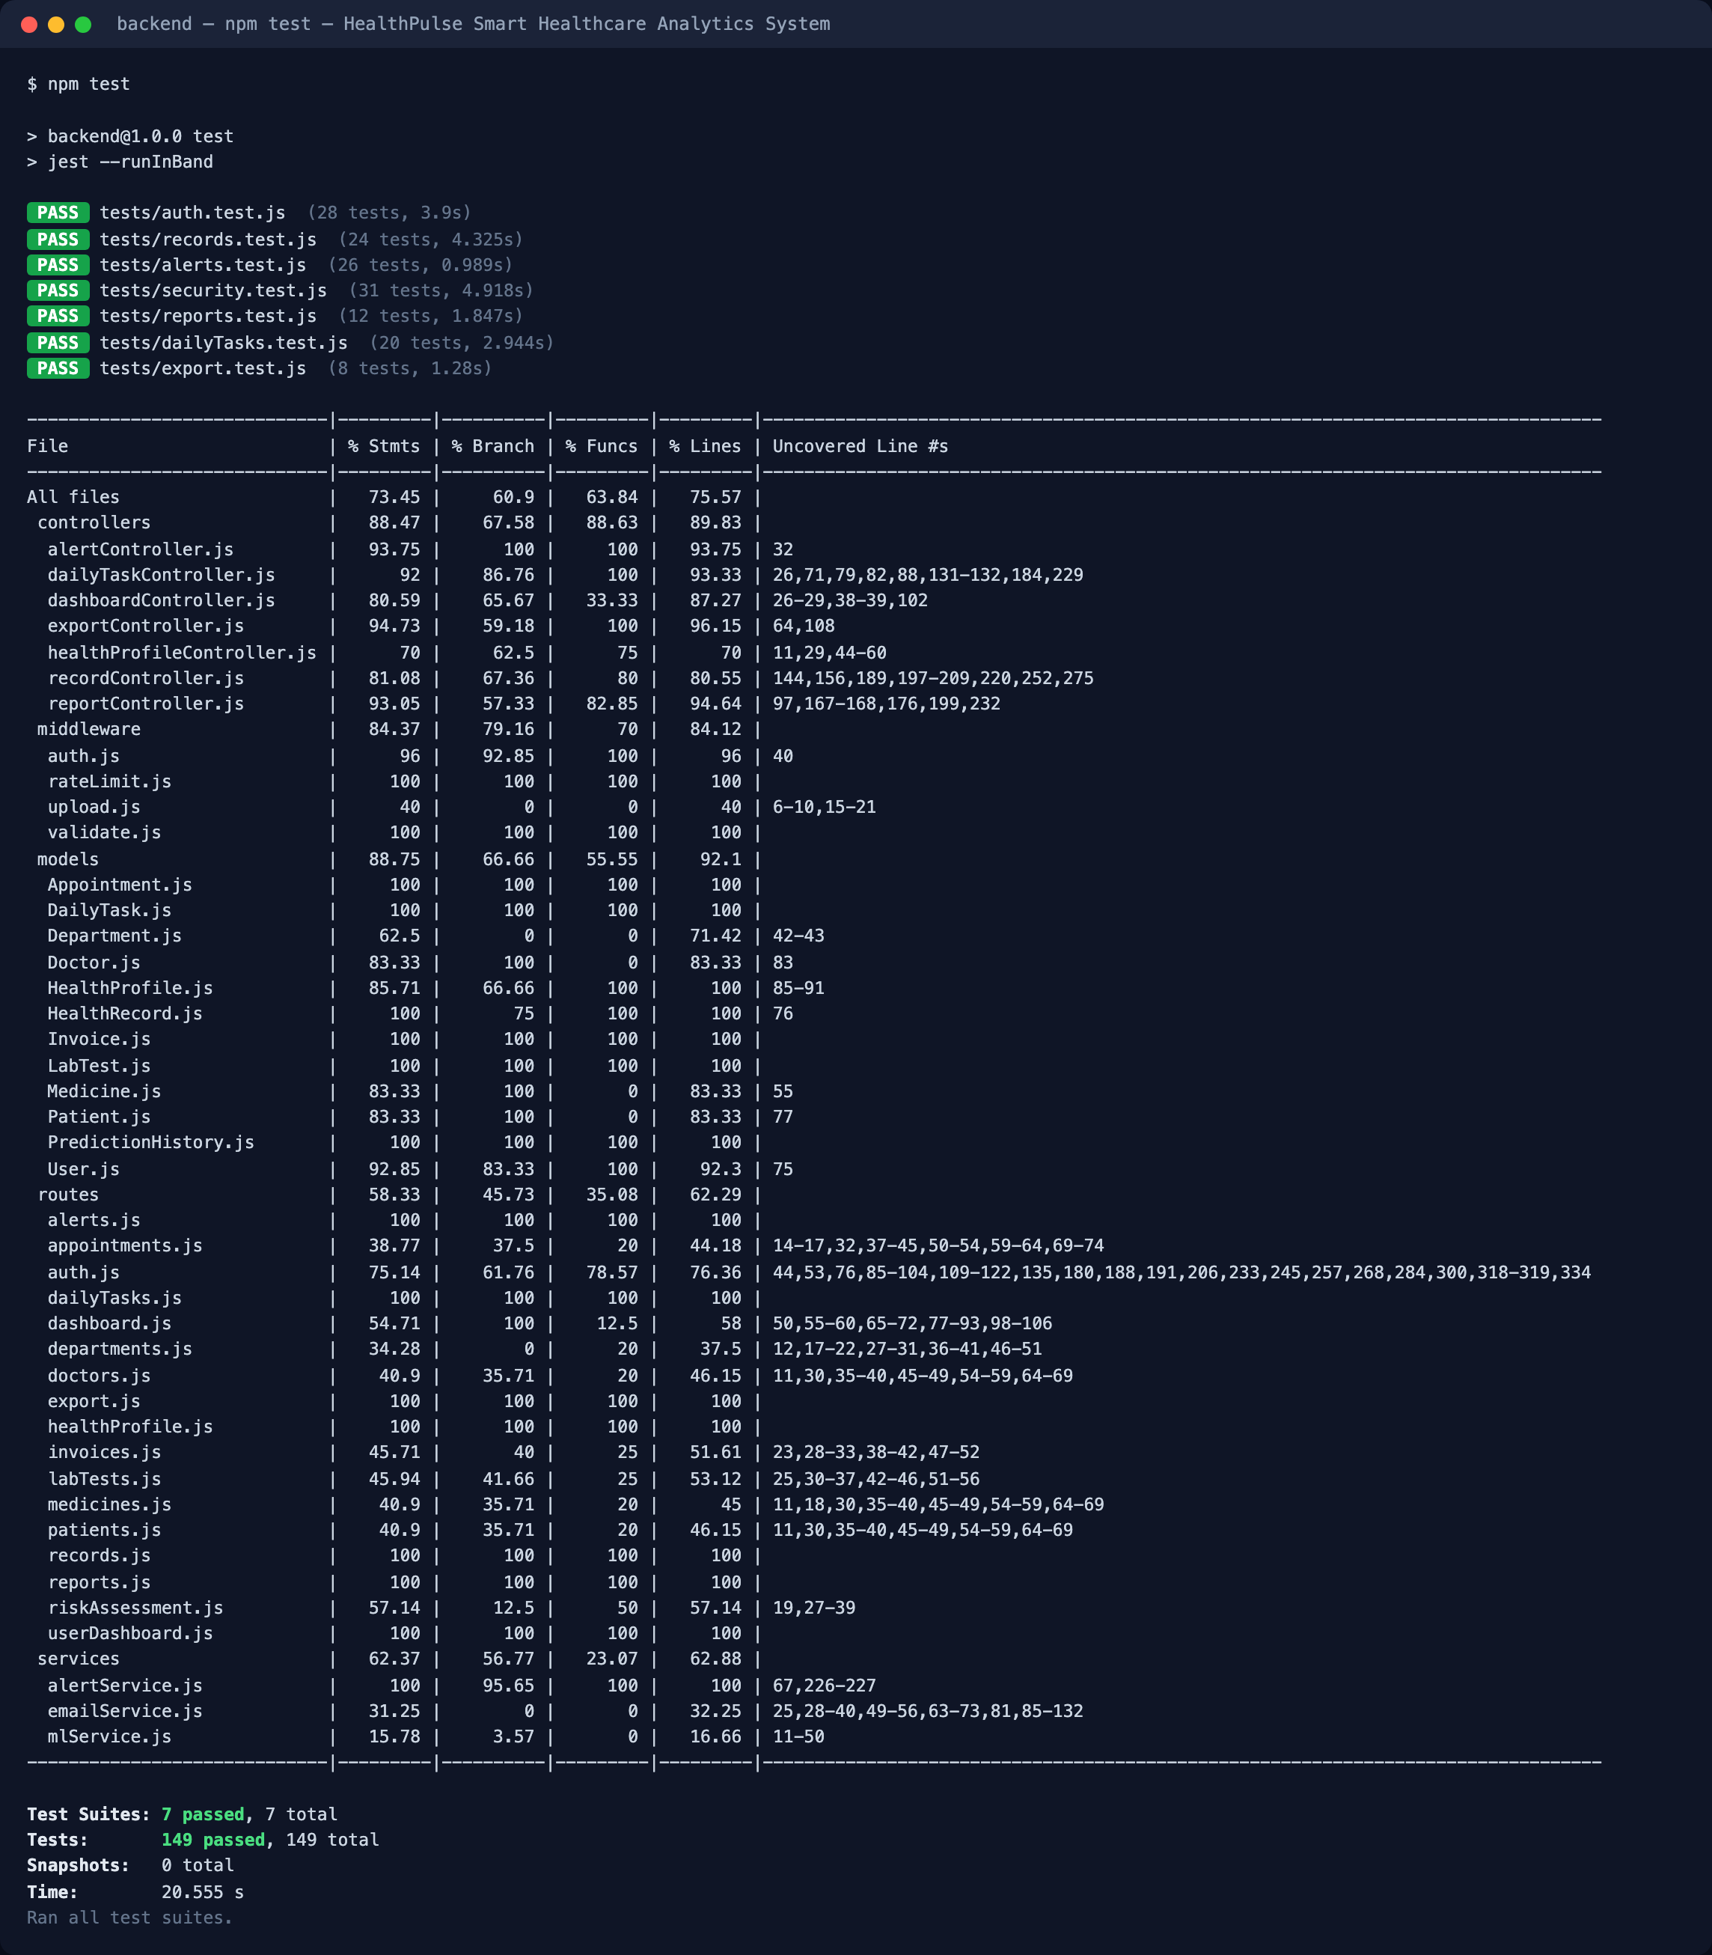
Description:
The output of the automated test suite, run with the npm test command. All seven suites and all 149 test cases pass. The coverage table produced in the same run reports 73.45 percent statement coverage overall and 88.47 percent across the controllers, with the alert engine, the rate limiter and the validation middleware fully covered.
Screenshot 4:
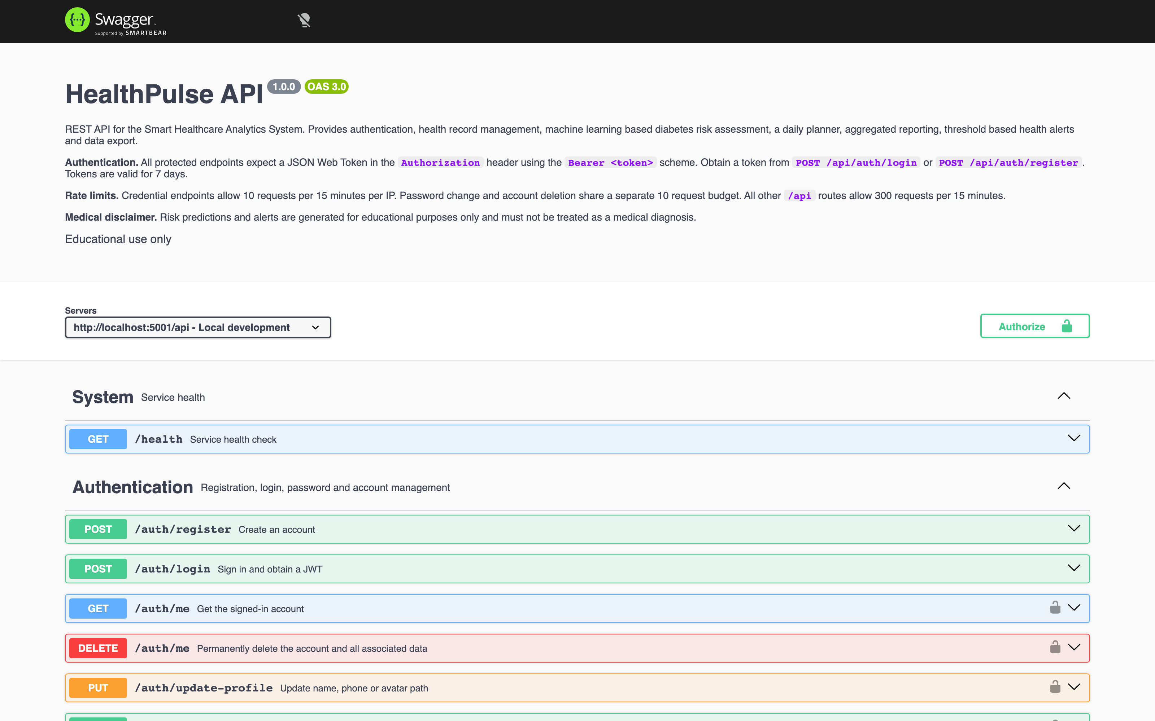
Description:
The interactive REST API documentation served at /api/docs. The page opens with the authentication scheme, the rate limits and the medical disclaimer, followed by the operations grouped by tag. A padlock on an operation marks it as requiring a JSON Web Token, and the Authorize button allows a token to be supplied so that any endpoint can be tried directly from the browser.
Screenshot 5:
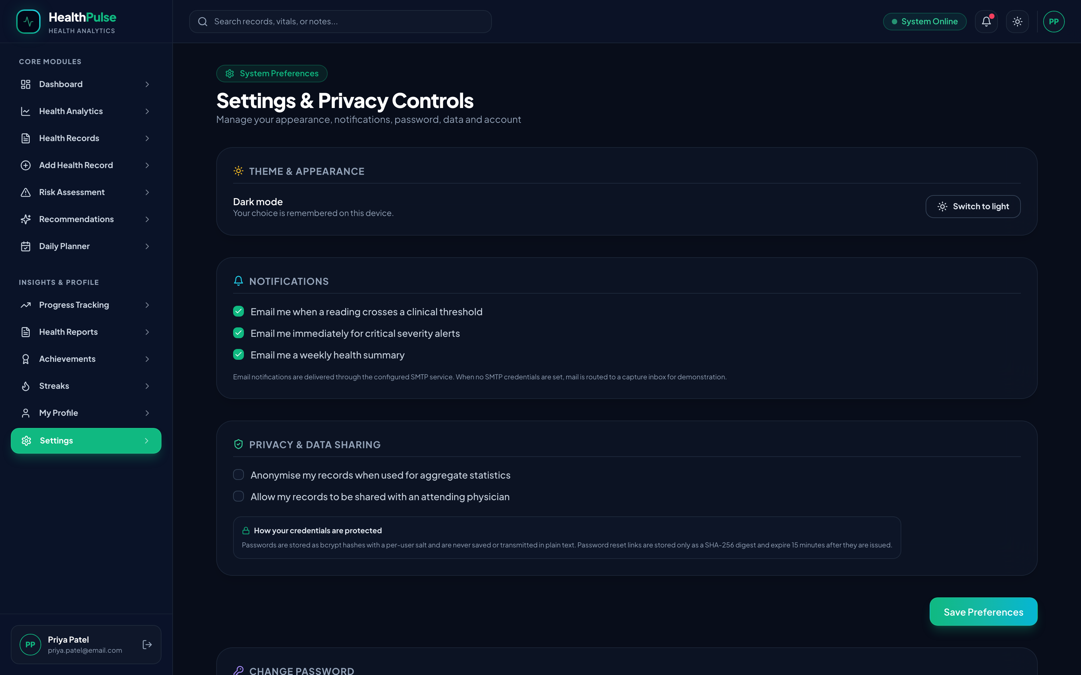
Description:
The Settings page, which was rebuilt in this phase. The notification and privacy preferences are now stored on the account rather than in the browser, the password can be changed after verification of the current one, the health data can be downloaded as CSV or as JSON, and the account can be deleted permanently after password confirmation. The note under the privacy section describes how credentials are actually protected, replacing the fixed label that was shown earlier.

All the screenshots given above were captured from the actual working application running with live data in the MongoDB database, and from the actual output of the automated test suite.

7. Final Results and Outcomes
☑ Completed
☐ Mostly Completed
☐ Partially Completed
☐ Work in Progress

Completed Components
Landing page and user interface. Authentication module with registration, login, forgot password delivered by email, reset password and change of password. Backend REST API server with 75 endpoints. MongoDB integration with 12 collections and 10 indexes. JSON Web Token authentication and role based authorization. Password encryption, rate limiting and server side input validation. Machine learning model training, evaluation and re-verification. Python FastAPI machine learning service and its integration with the backend. Health Records module with full create, read, update and delete operations. Risk Assessment module with prediction history. Daily Planner module with streak calculation. Health Profile module. Reports module with PDF export. Analytics module with clinical reference bands. Dashboard with aggregated statistics. Health Alert module. Data Export module producing CSV and JSON. Account preferences and permanent account deletion. Interactive REST API documentation. Automated test suite of 149 cases. Database seeder for demonstration data.

Pending Components
Cloud deployment of the frontend application, the backend server, the machine learning service and the database, together with the production environment configuration. Machine learning models for heart disease and hypertension risk prediction, which were planned in Reporting 3 and have not been started, because the available time in this phase was used for testing, documentation and the correction of the defects found during the code review. User acceptance testing with a wider group of external users, which is planned after deployment. Configuration of a production SMTP account, since the password reset mail is presently delivered to a capture inbox when no credentials are supplied. Multi language support for the interface.

8. References and Resources Used
References
[1] Smith, J. W., Everhart, J. E., Dickson, W. C., Knowler, W. C., & Johannes, R. S. (1988). Using the ADAP learning algorithm to forecast the onset of diabetes mellitus. Proceedings of the Annual Symposium on Computer Application in Medical Care, 261-265.
[2] Breiman, L. (2001). Random forests. Machine Learning, 45(1), 5-32. https://doi.org/10.1023/A:1010933404324
[3] Pedregosa, F., Varoquaux, G., Gramfort, A., Michel, V., Thirion, B., Grisel, O., Blondel, M., Prettenhofer, P., Weiss, R., Dubourg, V., Vanderplas, J., Passos, A., Cournapeau, D., Brucher, M., Perrot, M., & Duchesnay, E. (2011). Scikit-learn: Machine learning in Python. Journal of Machine Learning Research, 12, 2825-2830.
[4] Jones, M., Bradley, J., & Sakimura, N. (2015). JSON Web Token (JWT) (RFC 7519). Internet Engineering Task Force. https://doi.org/10.17487/RFC7519
[5] Whelton, P. K., Carey, R. M., Aronow, W. S., Casey, D. E., Collins, K. J., Dennison Himmelfarb, C., DePalma, S. M., Gidding, S., Jamerson, K. A., Jones, D. W., MacLaughlin, E. J., Muntner, P., Ovbiagele, B., Smith, S. C., Spencer, C. C., Stafford, R. S., Taler, S. J., Thomas, R. J., Williams, K. A., ... Wright, J. T. (2018). 2017 ACC/AHA guideline for the prevention, detection, evaluation, and management of high blood pressure in adults. Hypertension, 71(6), e13-e115. https://doi.org/10.1161/HYP.0000000000000065
[6] American Diabetes Association Professional Practice Committee. (2024). 2. Diagnosis and classification of diabetes: Standards of Care in Diabetes-2024. Diabetes Care, 47(Supplement 1), S20-S42. https://doi.org/10.2337/dc24-S002
[7] World Health Organization. (2000). Obesity: Preventing and managing the global epidemic (WHO Technical Report Series No. 894). World Health Organization.
[8] MongoDB, Inc. (2026). MongoDB manual: Indexes and query optimization. https://www.mongodb.com/docs/manual/indexes/ (Accessed September 2026)
[9] Meta Open Source. (2026). Jest documentation: Testing asynchronous code and setup files. https://jestjs.io/docs/getting-started (Accessed September 2026)
[10] OpenAPI Initiative. (2021). OpenAPI Specification version 3.0.3. https://spec.openapis.org/oas/v3.0.3 (Accessed September 2026)
[11] Reinman, A. (2026). Nodemailer documentation: SMTP transport and testing accounts. https://nodemailer.com/about/ (Accessed September 2026)
[12] OpenJS Foundation. (2026). Express 5.x API reference: Application and middleware. https://expressjs.com/en/5x/api.html (Accessed September 2026)

Evaluation (To be filled by Mentor (Institute))

Criteria | Excellent | Good | Average | Poor | Marks
Final Project Completion & Implementation | ≥90% meaningful work completed | 75–89% | 50–74% | <50% | /25
Functionality, Testing & Validation | Strong testing with evidence and analysis | Good testing | Limited testing | No meaningful validation | /25
Technical Understanding | Strong conceptual and technical understanding | Good understanding | Basic understanding | Unable to explain work | /20
Project Demonstration and Results | Complete, clear and well documented | Minor gaps | Incomplete documentation | Poor documentation | /20
References & Citations | Relevant, properly cited and formatted | Minor issues | Limited/relevant sources | Missing/improper | /10
TOTAL |  |  |  |  | /100

Evaluation
Student Signature | Mentor (Company)  Signature | Mentor (Institute)  Signature

Mentor (Institute) Remarks
________________________________________________________________________________________________________________________________________________________________________________________________________________________________________________________________________________________________________________________________________________________________________________________________________________________________________________________________________________________________________________________________________________________________________________________________________________________________________________________________________________________________________________________________________________________________________________________________________________________________________________________________________________________________________________________________________________________________________________________________________________________________________________________________________________________________________________________________________________________________________________________________________________________________________________________________________________________________________________________________________________________________________

